CS 255 System Design Document

This template lays out all the different sections that you need to complete for Project Two. Each section has guidance to prompt your thinking. You will need to continually reference the interview transcript as you work to make sure that you are addressing your client’s needs. There is no required length for the final document. Instead the goal is to complete each section based on what your client’s needs are. Remove this note when you are finished, and replace all bracketed text with the relevant information.

UML Diagrams

UML Use Case Diagram
[In Module Six, you were asked to complete a use case diagram based on your system design. If you would like to make any adjustments to your diagram, please do so. Please insert your use case diagram here. Check to make sure that you included appropriate components and symbols and that your design meets the client’s needs.]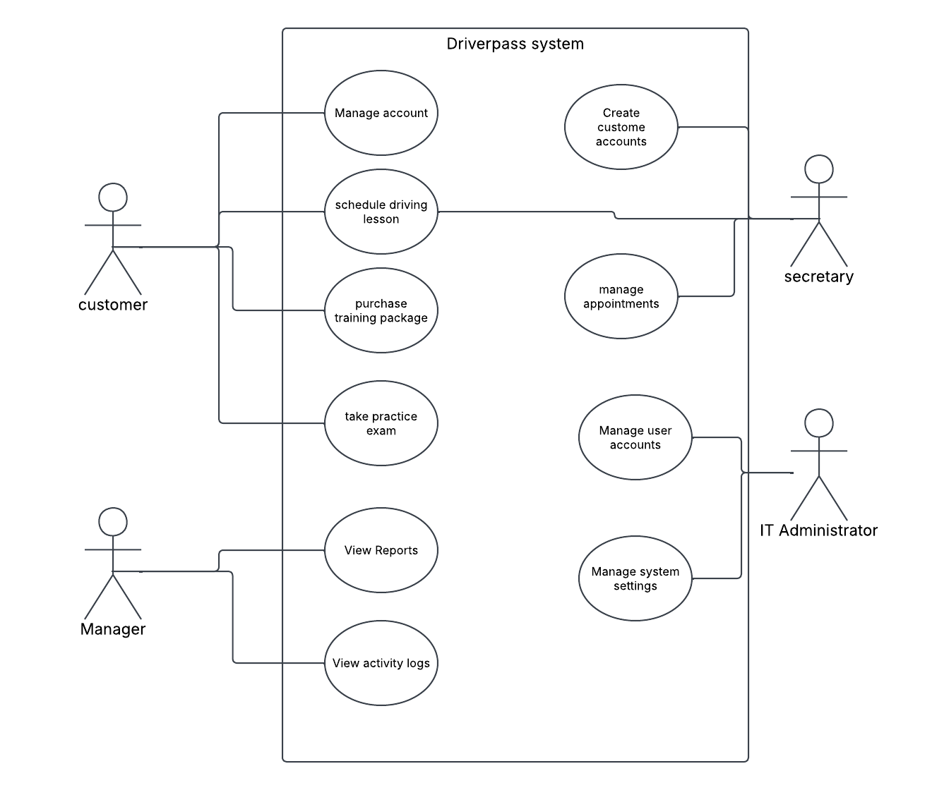

UML Activity Diagrams
[You were asked to choose two use cases and create two activity diagrams, one for each use case. Please insert both of your activity diagrams here. Check to make sure that you included appropriate components and symbols and that your design meets the client’s needs.]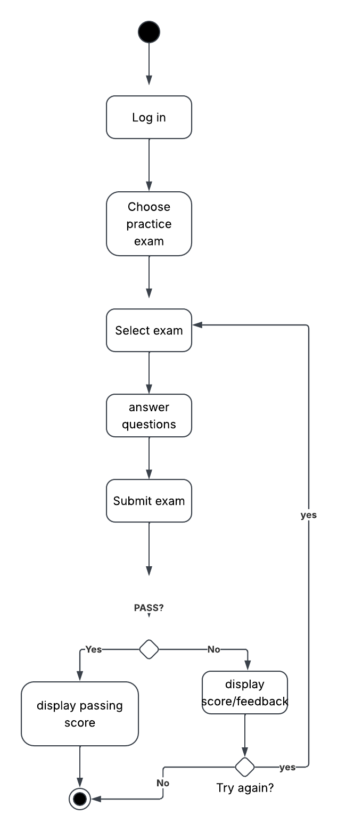
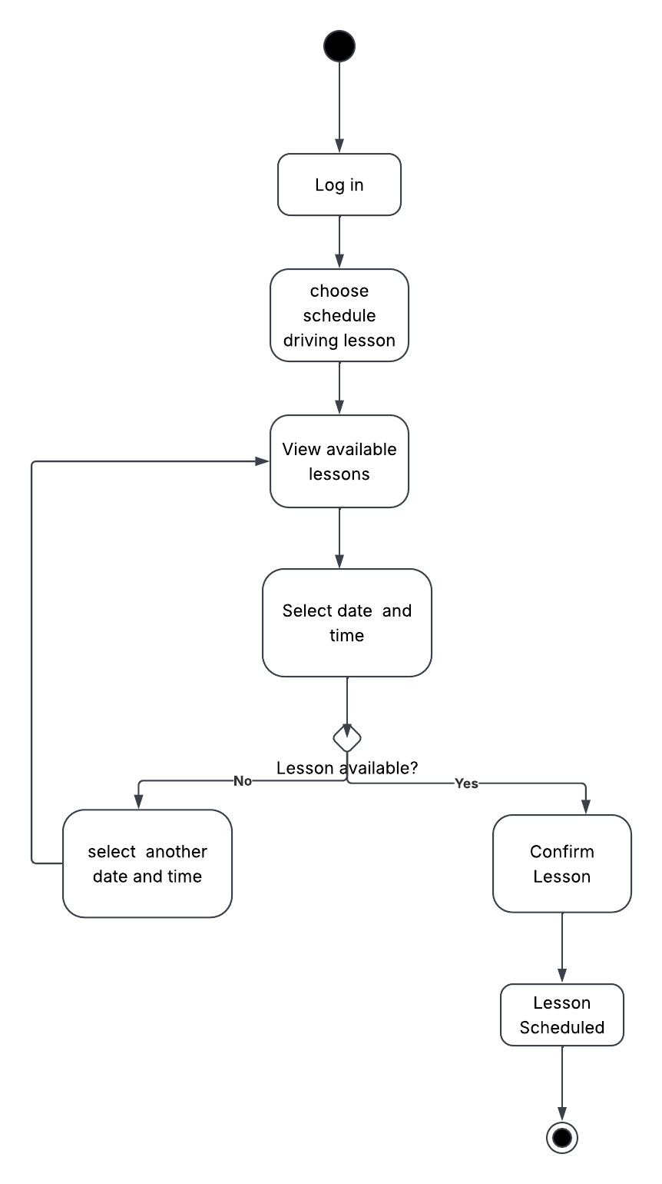

UML Sequence Diagram
[You were asked to create a sequence diagram based on one of the use cases you chose. Please insert your sequence diagram here. Check to make sure that you included appropriate components and symbols and that your design meets the client’s needs.]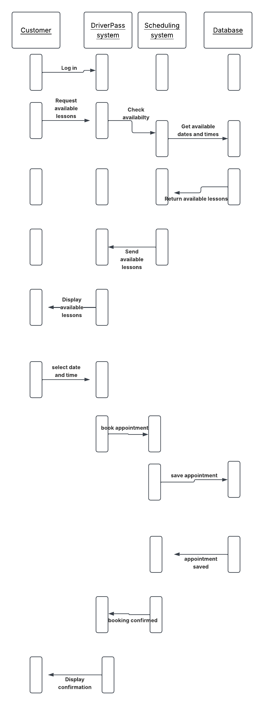

UML Class Diagram
[You were asked to create a class diagram based on the different classes and attributes needed for your system design. You are not required to include methods, but you may if you wish. Please insert your class diagram here. Check to make sure that you included appropriate components and symbols and that your design meets the client’s requirements.]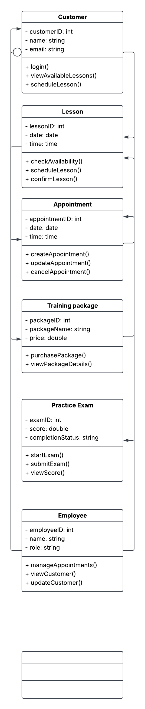

Technical Requirements
When I think about the technical side of DriverPass, I think the biggest thing is making sure the system is actually practical for both the customers and the employees using it every day. Since it will be web-based, customers should not need a certain type of computer or have to download another program just to use it. They should be able to pull it up on a phone, tablet, or computer and do things like check their practice test progress or schedule a driving lesson. Employees will need reliable computers and internet access since they will be using the same system to work with appointments and customer information.
There is also quite a bit of information happening behind the scenes that DriverPass will need to keep organized. Customer accounts, lesson schedules, training packages, test scores, and payment information will all need to be stored in a database. I would use cloud storage and backups so the company is not depending on one computer to hold important information. Security is also important because some of the information being stored is personal or related to payments. Another part I would plan for is change. DMV rules and practice test information will not always stay the same, so DriverPass needs to be able to update that information without causing problems with the rest of the system. I also think it makes sense to design it with some room to grow instead of only building it around what the company needs right now.

